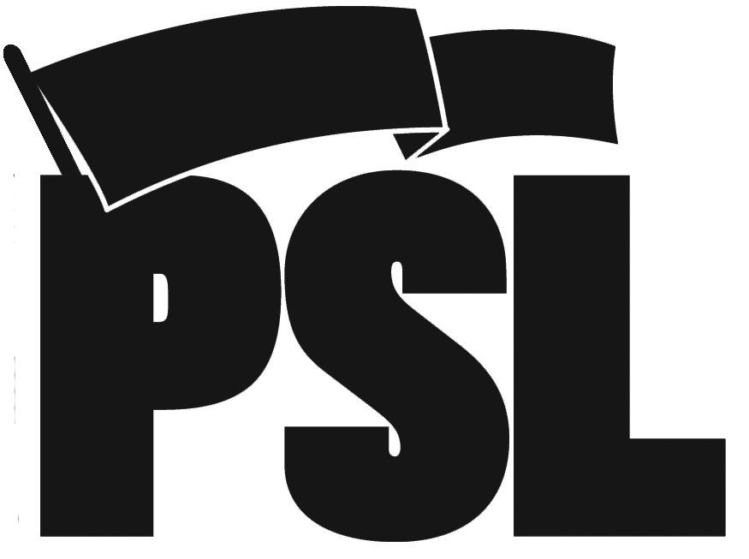
“Jigsaw” Assignments
Imperialism in the 21st Century: Class 2--Chapters 2 & 3

Instructions: Break into small groups or pairs. Assign each group an assignment 1 through 4. Repeat assignments if necessary, each group does their assignment a little differently.

Assignment 1: World War II and its results
Your task: Read your guiding question out loud. Work with your pair or group to skim over the sections listed below. Then design a poster to teach the rest of the class the most important concepts and/or terms that relate to your guiding question. Use drawings, words, phrases, whatever works best for your group.

Guiding QUESTION: How did World War Two re-shape the global political and economic situation?
Read “Soviet Union changes the equation” (pgs 31-top of 33) and (pgs 13-15, 17-19)
Helpful notes:
- in general a movement towards revolution: USSR’s military/strategic position; strength of communist parties vis-à-vis anti-fascist and anti-colonial resistance.
- Imperialists reorganize and restructure world order: Concentration of imperialist camp around USA
- movement from colonialism to neocolonialism in response to resistance
- built institutions of new imperialist world order
-----------------------------------------------------------------------------------------------------------------

Assignment 2: Global Class War
Your task: Read your guiding question out loud. Work with your pair or group to skim over the sections listed below. Then design a poster to teach the rest of the class the most important concepts and/or terms that relate to your guiding question. Use drawings, words, phrases, whatever works best for your group.

Guiding QUESTION: What was the Global Class War?
Read pgs 33-35 and pgs41-42
Helpful notes:
- Two irreconcilable class camps
- From imperialist perspective, it’s the elimination of inter-imperialist rivalry and the all-out efforts to eliminate communist, socialist and national liberation movements

-----------------------------------------------------------------------------------------------------------------

Assignment 3: Sino-Soviet Split; the overthrow of USSR
Your task: Read your guiding question out loud. Work with your pair or group to skim over the sections listed below. Then design a poster to teach the rest of the class the most important concepts and/or terms that relate to your guiding question. Use drawings, words, phrases, whatever works best for your group.

Guiding QUESTIONHow did the Sino-Soviet split change the balance of forces in the global class war?
Read “imperialist war drive continues in new forms” pgs 42-44 and The Sino-Soviet Split document (as highlighted)
Helpful notes:
- during the global class war, the main trend was toward revolution. ”it was the division of within the socialist bloc nations between the soviet union and the people’s republic of China… which changed this relationship of forces.”
- the Sino-soviet split was an ideological struggle that became a state vs. state struggle that U.S. imperialism took full advantage of
- the overthrow of the USSR brought about a new stage of imperialist struggle

-----------------------------------------------------------------------------------------------------------------

Assignment 4: Unipolar Era of Imperialism
Your task: Read your guiding question out loud. Work with your pair or group to skim over the sections listed below. Then design a poster to teach the rest of the class the most important concepts and/or terms that relate to your guiding question. Use drawings, words, phrases, whatever works best for your group.

Guiding QUESTION: What is the unipolar era of imperialism?
Read “the creation of a unipolar world” 45-48 and “the end of neutrality” 49-50

